CRC
Block
Cyclic Redundancy Check

{28/12/2025}

Chedva Sebbag
Avigayil Resnick
Shira Suli

Content

Glossary and references 3
references 4
RTL Block Description 4
RTL Block Diagram 5
DUT interface 6
Verification Block Diagram 6
Verification Checkers and Assertions 7
Waves 8
Test List 8
Coverage Plan 9
Coverage Result 9
Disclaimers 9
Open Issues / TODO List 10

Glossary and references
Glossary
CRC (Cyclic Redundancy Check)
An error-detecting code computed by interpreting the input data as a polynomial over GF(2) and performing polynomial division by a generator polynomial. The remainder of this division is the CRC checksum.
CRC-3 / CRC-8 / CRC-16 / CRC-32
CRC configurations supported by the hardware block. The number indicates the degree of the generator polynomial and the width (in bits) of the CRC result. Only the least significant 3, 8, 16, or 32 bits of `crc_out` are valid for each respective type.
CRC Polynomial / Generator Polynomial
The polynomial over GF(2) used as the divisor in the CRC calculation. It defines the feedback taps in the hardware implementation and determines the properties of the CRC code.
GF(2) (Galois Field of order 2)
A binary field with two elements {0,1}. Addition is equivalent to bitwise XOR and multiplication to bitwise AND. All CRC operations are defined over this field.
LFSR (Linear Feedback Shift Register)
A shift register with XOR feedback paths used to implement the CRC calculation in hardware. In the parallel version, a 32-stage LFSR allows processing a 32-bit data word in a single clock cycle.
`data_in[31:0]`
32-bit input data word for which the CRC checksum is computed.
`crc_init[31:0]`
Initialization value loaded into the CRC register before starting a calculation. In continuous mode it can be set to the previous `crc_out` to create a cumulative CRC over multiple data blocks.
`crc_out[31:0]`
32-bit output of the CRC block. Depending on the selected CRC type (`crc_select`), only the least significant 3, 8, 16, or 32 bits are considered valid.
`crc_select`
Control signal that selects the CRC type (CRC-3, CRC-8, CRC-16, or CRC-32) and indirectly selects the corresponding generator polynomial and valid width of `crc_out`.
`data_valid`
Input control signal indicating that `data_in`, `crc_init`, and `crc_select` are valid and should be sampled and processed by the CRC block.
`crc_valid`
Output control signal indicating that `crc_out` holds a valid CRC result corresponding to the last accepted input data word.
Single Calculation Mode
Operational mode in which the block performs one CRC computation for a single 32-bit data word, starting from `crc_init` and producing a single valid `crc_out`.

Continuous Calculation Mode
Operational mode in which multiple 32-bit data words are processed as a sequence. The `crc_out` of one word can be used as `crc_init` for the next word, enabling a cumulative CRC over multiple data blocks.
DUT (Device Under Test)
The CRC hardware block being verified in the testbench environment.
Reference Model (Golden Model)
A bit-accurate software model of the CRC algorithm used in the verification environment to compute the expected CRC value, based on `data_in`, `crc_init`, and `crc_select`.
Scoreboard
Verification component that compares the CRC result from the DUT (`crc_out`) with the expected result computed by the reference model whenever `crc_valid` is asserted.
Assertion
A formal property (e.g., in SystemVerilog Assertions) that checks protocol and timing rules, such as valid reset behavior, stable inputs on `data_valid`, or correct timing between `data_valid` and `crc_valid`.

references
[1] Standard descriptions of Cyclic Redundancy Check (CRC) algorithms from
publicly available technical documentation.
[2] Online educational resources and tutorials on CRC theory and hardware
implementation concepts.
[3] IEEE 1800 SystemVerilog Language Reference Manual.
[4] Universal Verification Methodology (UVM) User Guide.

RTL Block Description
The CRC block is implemented as a synchronous RTL module clocked by `clk` and reset asynchronously by `rst_n`. It receives a 32-bit input data word together with configuration and control signals, and produces a CRC checksum according to the selected CRC type (CRC-3, CRC-8, CRC-16, or CRC-32). All state updates occur on the rising edge of `clk` when `rst_n` is de-asserted.

Internally, the block is organized around a 32-bit CRC state register (`crc_reg`) and a combinational CRC computation core. The CRC state register holds the current CRC value used during the calculation. At the start of a calculation, `crc_reg` is initialized with the value provided on `crc_init`. For each valid input data word, the combinational core computes the next CRC value (`crc_next`) based on the current state and the 32-bit `data_in` word, following the polynomial division algorithm over GF(2) described in the specification.

The CRC computation core is implemented as a parallel 32-bit XOR/shift network derived from the selected generator polynomial. Instead of processing one bit per cycle, the logic is arranged as a 32-stage linear feedback structure that processes all 32 bits of `data_in` in a single clock cycle. The effective polynomial used by the core is selected by decoding `crc_select`, which chooses between the CRC-3, CRC-8, CRC-16, and CRC-32 generator polynomials. This decoding controls the feedback taps of the XOR network and determines the resulting CRC width.

On every cycle in which `data_valid` is asserted, the block samples `data_in`, `crc_init` (for the first block of a sequence), and `crc_select`. The sampled configuration and data are driven into the CRC computation core, which produces `crc_next`. On the following rising edge of `clk`, `crc_reg` is updated with `crc_next`, and the updated value is made visible at the output register driving `crc_out`. At the same time, `crc_valid` is asserted to indicate that `crc_out` holds a valid CRC result corresponding to the last accepted input word. When `data_valid` is de-asserted, no new CRC computation is started and `crc_reg` and `crc_out` retain their previous values.

The block supports both single calculation and continuous calculation operation, as defined in the specification. In single calculation mode, each assertion of `data_valid` is treated as an independent transaction: `crc_reg` is initialized from `crc_init`, a single 32-bit word is processed, and `crc_valid` is asserted when `crc_out` is ready. In continuous calculation mode, the system reuses the CRC result of one block as the initialization value for the next block. Functionally, this is achieved by supplying the previous `crc_out` value on `crc_init` for the subsequent transaction, allowing the same RTL datapath to be used seamlessly for chained CRC computations across multiple data blocks.

Output handling is performed by a small output formatting stage that derives the externally visible CRC value from the internal 32-bit state. The full 32-bit `crc_reg` value is driven to `crc_out`, but only a subset of the bits is considered meaningful depending on `crc_select`: for CRC-3 only bits [2:0] are used, for CRC-8 bits [7:0], for CRC-16 bits [15:0], and for CRC-32 the entire 32-bit value is valid. The upper unused bits are not interpreted by the system and are ignored by the verification environment when checking correctness.

Reset handling is centralized around `rst_n`. When `rst_n` is asserted low, `crc_reg`, `crc_out`, and `crc_valid` are all driven to known reset values (typically zero), and no new data is accepted regardless of `data_valid`. When `rst_n` is de-asserted, the block returns to its idle state and is ready to start a new CRC calculation on the next assertion of `data_valid`. This structure provides a clean and deterministic initialization point for both single and continuous calculation modes.

RTL Block Diagram
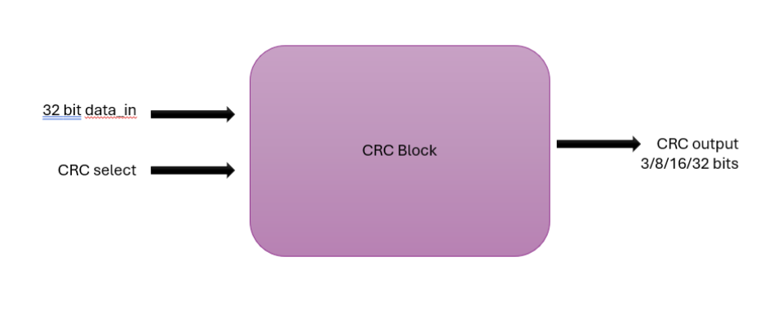
The CRC hardware block consists of a control unit that manages the operation flow, a polynomial selector that selects the CRC polynomial according tocrc_select, and a parallel CRC calculation engine based on an LFSR/XOR network. The CRC register stores the intermediate and final CRC values, while the output logic generates crc_out and crc_valid signals according to the selected CRC mode.

DUT interface

The CRC block interfaces with the environment through the following signals.
The interface includes six input signals (clock, reset, control and data inputs) and three output signals (CRC result and status indications), as detailed in Table .

Signal name | IO type | Width | Description
clk | Input | 1 | System clock – 120MHz
rst_n | Input | 1 | Active low reset
data_in | Input | 32 | Input data for CRC calculation
data_valid | Input | 1 | Indicates valid data is present on data_in
crc_select | Input | 2 | Selects CRC polynomial (00:CRC-3, 01:CRC-8, 10:CRC-16, 11:CRC-32)
crc_init | Input | 32 | Initial value for CRC calculation
crc_out | Output | 32 | CRC calculation result (width depends on selected CRC)
crc_valid | Output | 1 | Indicates valid CRC result is available
busy | Output | 1 | Indicates the block is processing

Verification Block Diagram

The verification environment for the CRC hardware block is based on a UVM
testbench architecture. The environment drives stimulus to the DUT, monitors
its behavior, and checks functional correctness against a reference model.

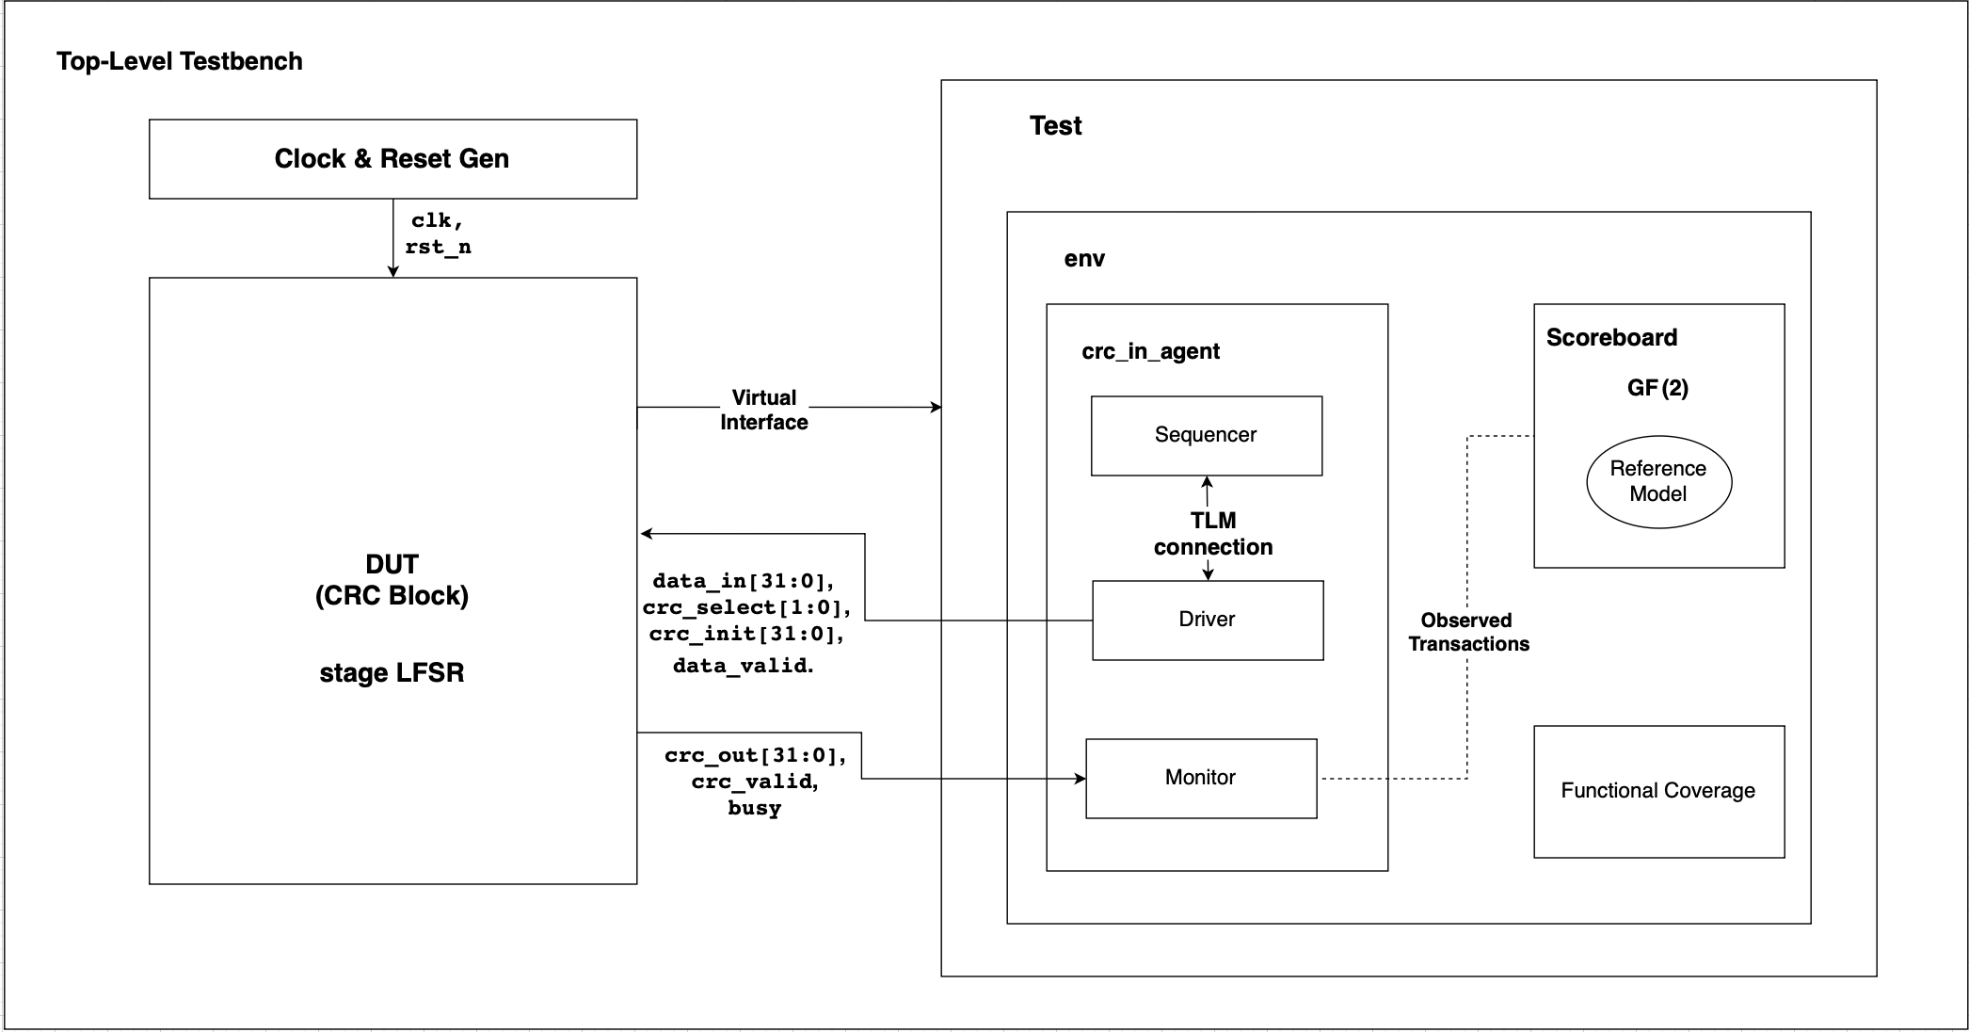

Verification Checkers and Assertions

Functional checkers and SystemVerilog assertions are used to verify the
correctness and protocol behavior of the CRC hardware block.
Functional checkers are implemented in the scoreboard and compare the CRC
value generated by the DUT with an expected value calculated by a reference
model. The checker verifies correct CRC calculation for all supported CRC
polynomial options and operational modes.
SystemVerilog assertions are used to verify correct timing and control behavior
of the DUT. Assertions ensure that crc_valid is asserted only after valid input
data is provided, that busy is asserted while the block is processing, and that
all outputs are properly reset when rst_n is deasserted.
Any violation detected by the checkers or assertions is reported as a
verification error.

Waves
Waveforms will be used to observe the functional behavior of the CRC block.
The following signals will be monitored:
clk, rst_n, data_in, data_valid, crc_select, crc_init, busy, crc_valid, crc_out.
A CRC operation is initiated by asserting data_valid with stable input signals.
During computation, busy is asserted.
When the calculation is complete, crc_valid is asserted and crc_out is updated
with the corresponding CRC result.
Waveforms will also demonstrate correct behavior following reset and
across multiple CRC operations.

Test List

Test name | Description | Number of tests running in regression
Reset Test | Verifies correct reset behavior of the CRC block, and proper return to idle state after reset de-assertion. | 1
Single CRC Calculation Test | Verifies correct CRC calculation for a single input transaction using valid data, initialization value, and CRC selection. | 1
CRC Selection Test | Verifies correct operation for all supported CRC types. (CRC-3, CRC-8, CRC-16, CRC-32) | 1
Continuous Mode Test | Verifies correct chained CRC operation by reusing the previous CRC result as the initialization value for the next calculation. | 1
Busy Handling Test | Verifies correct behavior when input in data is provided while the CRC block is busy processing a previous transaction. | 1
Multiple Sequential Operations Test | Verifies correct behavior across multiple consecutive CRC calculations without reset between transaction. | 1

Coverage Plan

Coverage Item | Bins | Sample Time | Description / Comment
CRC Type Coverage | CRC-3, CRC-8, CRC-16, CRC-32 | On data_valid | Ensures all supported CRC types are exercised.
Reset Coverage | Reset asserted/ de-asserted. | On rst_n | Ensures correct behavior following reset.
Operation flow coverage | Single and Multiple operation | On crc_valid | Verifies correct CRC calculation flow across transaction.
Continues Mode Coverage | Chained operations | On crc_valid | Verifies cumulative CRC operation using previous results.
Control Signal Coverage | Busy and crc_valid asserted | During operation | Ensures correct indication of processing and completion.

Coverage Result
Coverage results will be collected and updated after running the full regression.

Disclaimers
The verification effort focuses on functional correctness only.
Performance analysis, power consumption, timing closure, and corner-case timing analysis are out of scope for this project.

Open Issues / TODO List
- Coverage results to be updated after execution of the full regression.
- Final review of assertions and checkers after testbench stabilization.
- Additional stress or corner-case tests may be added if required.

